Get Initialization VM Report

# Overview

It provides the initialization status of a VM possessed by a user i.e. it tells if a VM has been initialized or uninitialized or if it is not applicable for initialization (in case the VM is blank or created as a custom template). Now the requester can be a Business group or one of its users. The final Report shows status of all the VMs Possessed by a Business Group or its Users.

# Goal

It is prepared to get the initialization status of a VM as there were no mode existing to know if applicable, a VM has been initialized or not.

# Solution /Logic design

If NO end

Is request_org ==

bg

Get request Name, request organization,requested by,request State

vcacCAFEHsot

findRequests(vcacCAFEHost,“Initialize VM”)

IF YES

Split request Name. For each part of the VM NAME concatenate them with “-”

If request state == ‘successful’

IF NO end

Put vm name and requester in map ‘initializedVM’

Fetch VM details of a BG through

Action “getVMs”

If given user has “-o- in its name”

If NO

If (vm owner == given user)

IF yes

Put all the vms of that bg in map ‘bgVMs’ along with the owner

Put vms of that user only in map ‘bgVMs’ along with the owner

If vms in bgVMs exists in intializedVMs

IF yes

vmState =“Initialized”

IF NO

vmState = “Uninitialized”

If VM Blueprint has phrases ‘match’ or ‘blank’ in its name

IF NO

vmState = ‘Uninitialized’

IF YES

vmState = ‘Not Applicable’

Push required data to array and write it in a file through action ’WriteDataToFile’ and send with the mail through workflow ’send Mail’

end

# VM properties

* VM Name – Name of the virtual Machine.
* Initialization status – It tells if a VM is initialized, uninitialized or not applicable for initialization.
* VM IP Address - IP of a virtual Machine.
* Operating System – OS mount on VM.
* Owner – the one who owns/Created a VM.

Dependencies

# Related Actions

* WriteDataToTheFile – It writes the requested data to the provided file.
* ValidateEmail – It validates the mail Address.
* getVMs - It is a function which provides VMs and its data related to a Particular BG.
* GetOCfromVMproperties - get OC value of a BG( we are working with the substring of OC here) through VM properties.
* getResourcesOfBG - get all the resources i.e. services, custom templates, VMs, blueprints related to a particular bg.
* getProvisioningGroupEntityByName – It gets the entity set of provisioning group properties related to a VM from vCentre.

# Related WorkFlows

* Send Mail – It attaches the file with the mail and send it to the requester.

# Related Configuration elements

* fromName – Sender’s name who is sending the mail
* fromAddress – Sender’s email address
* vCACCAFEHost – host through which VRO connect with VRA to fetch the required data.
* vCACHost – host through which VRO connect with Iaas services of VRA.
* SmtpHost – with which one will be able to connect to the server to send the mail.
* CcAddress – it includes other member’s mail address to whom requester wants to send the mail.
* smtpPort - with which one will be able to connect to the server to send the mail.

# Attributes

These are the attributes used in the workflow which are self-explanatory from the picture.

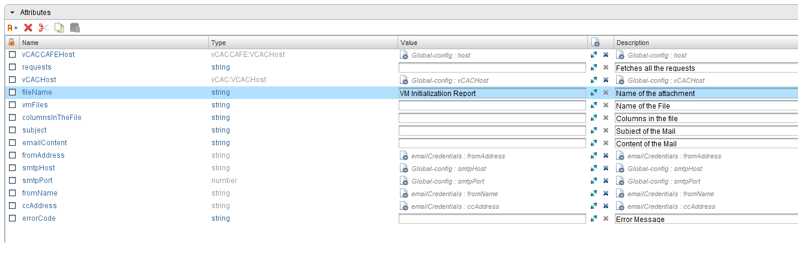

# Inputs

These are the inputs used in the workflow which are self-explanatory from the picture.

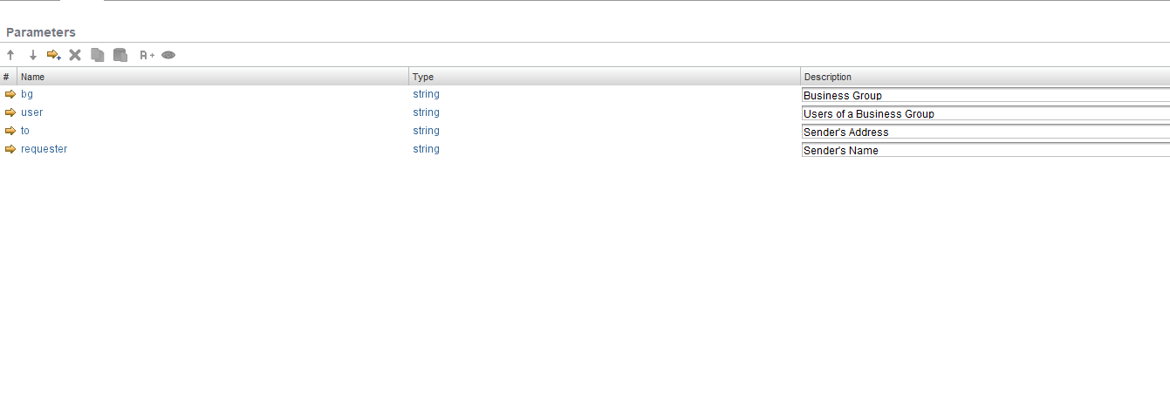

# Future scope

* The initialization status can be provided as a custom Properties of any VM so that every VM’s status can be known from the VM itself rather than going to the tedious procedure of reading a report.